Bug Report - 03:

Locked account warning remains on screen after unlocking
Environment: Windows 11, Opera GX
Test Object: PIN Authentication / UI State

Preconditions:
- The website is open
- The account 12345678 was previously locked due to 3 failed attempts
- The Admin unlocked the account successfully from the Admin Panel

Steps:
- Enter the account number 12345678 and submit
- View the PIN entry screen

Expected Result:
- The screen should not display any error messages since the account is now active and unlocked

Actual Result:
- The red error message 'Account locked after 3 attempts!' is still displayed below the PIN fields
Attachment:
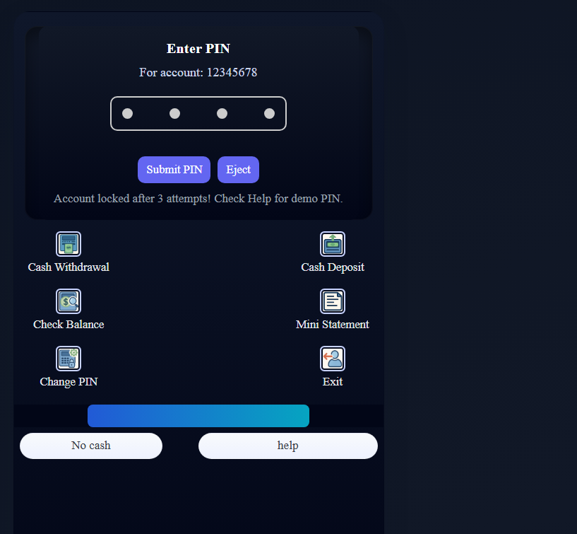
Severity: Medium
Priority: Medium

